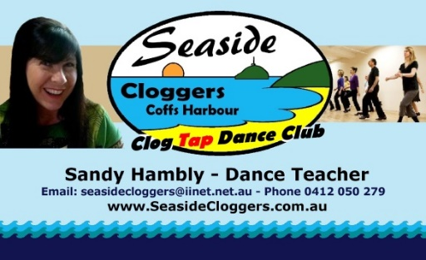
PLEASE CONTACT SANDY TO REGISTER YOUR INTEREST AND BOOK A SPOT – PHONE: 0412 050 279
Email: seasidecloggers@iinet.net.au Website: www.seasidecloggers.com.au

2018 WORKSHOPS / PRIVATE TUITION AVAILABLE
BEGINNER WORKSHOPS (90 MINS - $25) –DESIGNED FOR:
- BEGINNERS WHO HAVEN’T TAKEN ANY WORKSHOPS OR CLASSES AT ALL OR …

- BEGINNERS WHO HAVE TAKEN SOME CLASSES AND ARE NEEDING EXTRA HELP TO GRASP THE FUNDAMENTAL STEPS OF CLOG TAP.
BASIC PLUS WORKSHOPS (90 MINS - $25) – DESIGNED FOR:
- BEGINNERS WHO KNOW THE BASICS AND WANT TO TAKE THEIR DANCING TO THE NEXT LEVEL AND REFINE STEPS THEY MAY BE STRUGGLING WITH.

- BEGINNERS WHO WANT TO LEARN THE DANCES TO COMPLETION SO THEY CAN KEEP UP WITH OTHER STUDENTS AT THE REGULAR CLASSES.
HIGHER LEVEL WORKSHOPS (90 MINS - $25) – DESIGNED FOR:
- STUDENTS WHO HAVE BEEN COMING A WHILE AND READY TO STEP UP INTO THE NEXT LEVEL WITH HARDER STEPS AND ROUTINES.
NOTE: FOR ALL 90 MIN WORKSHOPS - Minimum of 4 students)
PRIVATE TUITION (1 STUDENT either CHILD OR ADULT) –
($25 PER HOUR ADULT/$20 PER 45MINS CHILD)
- YOU CHOOSE WHAT YOU WANT TO LEARN. THIS IS TOTALLY TAILOR MADE JUST FOR YOU.
SHARED-PRIVATE TUITION (2 STUDENTS ) – ($20/HOUR/STUDENT)
- CONCENTRATED TUITION FOR EACH INDIVIDUAL STUDENT OF ANY LEVEL (BEGINNER LEVEL UP). GREAT FOR FRIENDS OR DANCE MATES WHO ARE ON A SIMILAR LEVEL.
ALL ABOVE WORKSHOPS ARE HELD IN WOOLGOOLGA
_____________________________________________________________________
PRIVATE LESSONS/WORKSHOPS AVAILABLE AT COFFS HARBOUR

Playhouse Party Room – Tuesdays (School terms only)
5.00 – 5.30pm (Private Lesson/Workshop any level for children or adults)
Prior booking essential ($15 one student/$10 each 2 students/$9 each 3+ students)
7.15 – 7.45pm (Private Lesson/Workshop any level adults)
Prior booking essential ($15 one student/$10 each 2 students/$9 each 3+ students)

Shoe hire available at $2 per lesson (subject to sizes available)

